Suisse - Schweiz - Svizzera

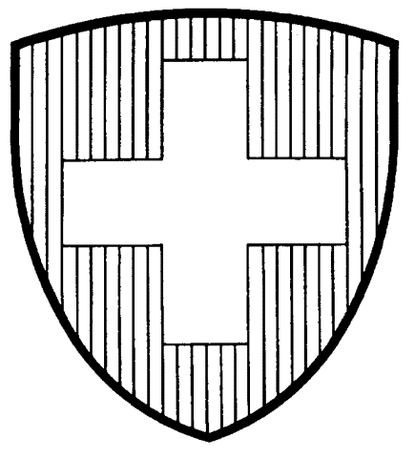

ATTESTATION FOR EXPORTATION - Cosmetics

Exporter declaration:
Exporter : |  |  |  | Country of production of goods :
Consignee: |  |  |  | Country of destination :
Means of conveyance : |  |  | Invoice number :
Description of products :

Gross mass (kg) : | Net mass (kg) : |  | Number and kind of packages : | Marks and batch numbers :
The undersigned confirms that :
- the above mentioned products are intended for use on human skin
- these products were manufactured under strict hygienic conditions, according to the rules of good manufacturing practice, and are in conformity with the Swiss Federal Regulations on Commodities and Cosmetics
- these products can be freely sold in Switzerland
- these products are not, to the present state of knowledge, harmful to human health
- the company that produced these goods has implemented a quality assurance system

Enclosures :

Name and function : |  | Place : | Date : | Signature :

Official authority attestation:
The undersigned Official Food Law Enforcement Authority certifies that all cosmetics and their ingredients brought into circulation in Switzerland must be produced according to the regulations of the Federal Commodities and Cosmetic Directives. According to these regulations, the products have to be produced under strict hygienic conditions and may not contain any substances which could be harmful to health in character or amount. In these respects the company is under regular control by the Official Food Law Enforcement Authorities.
The head of the official authority :

Certificate No : | Place : | Date : | Signature and stamp :

